ADOBE FORM

FOR DEMO

FP_EXAMPLE_01

GO TO T CODE - SFP

FIRST CREATE AN INTERFACE

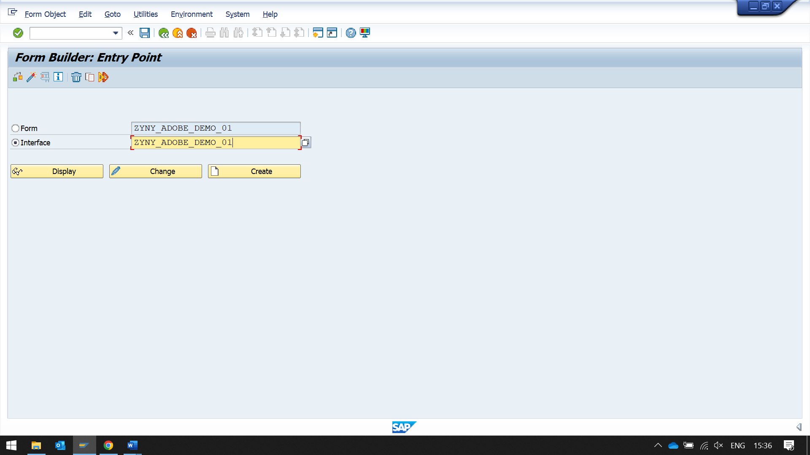

IN IMPORTS CREATE PARAMETERS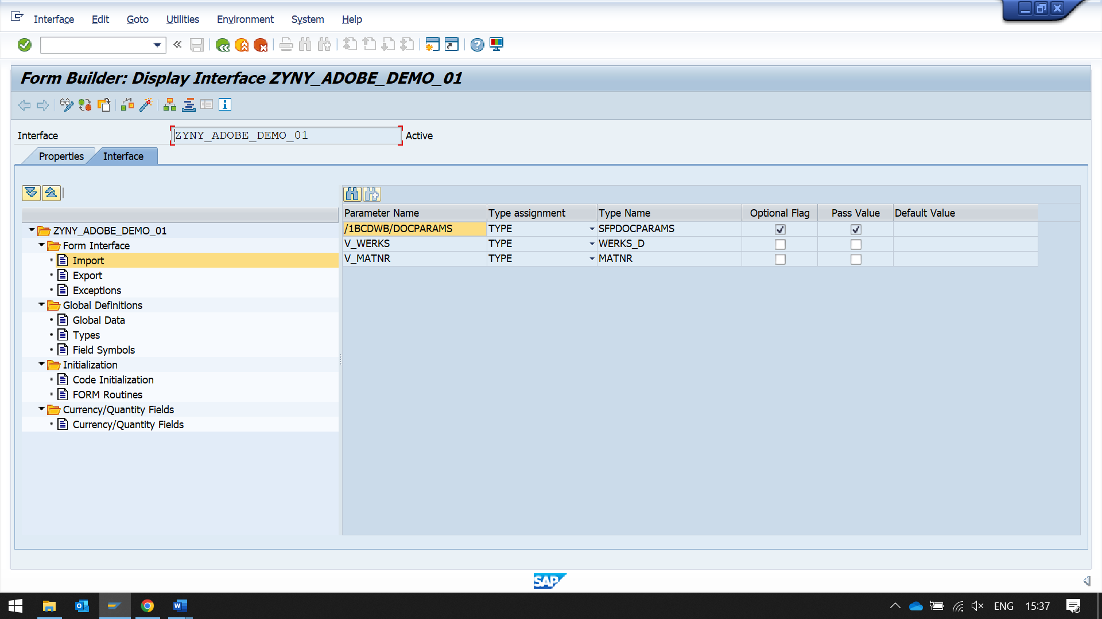

THEN CREATE A FORM TO USE THE INTERFACE

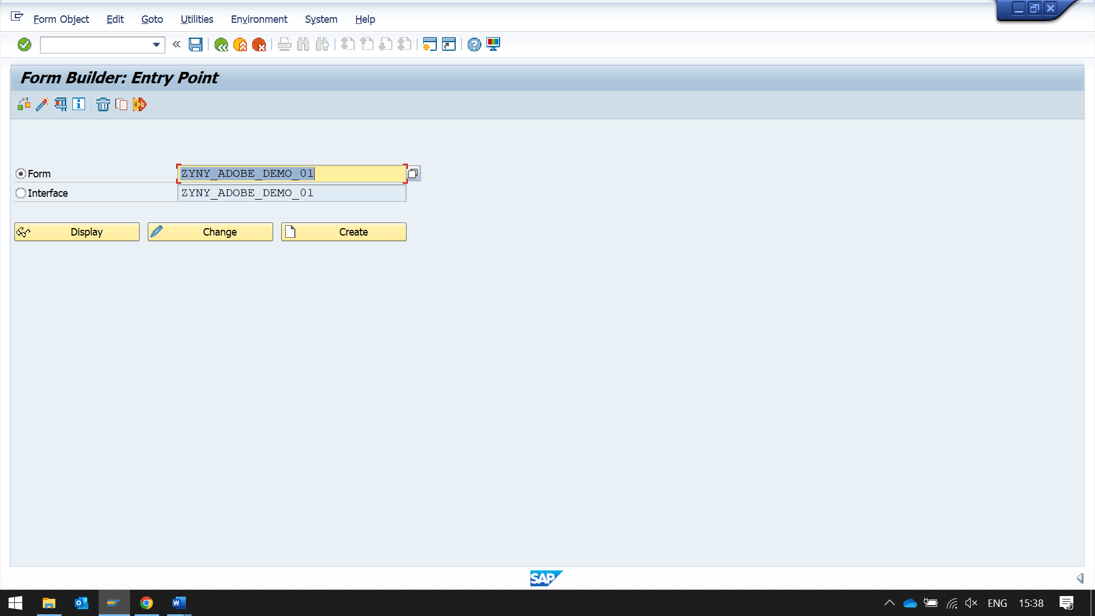

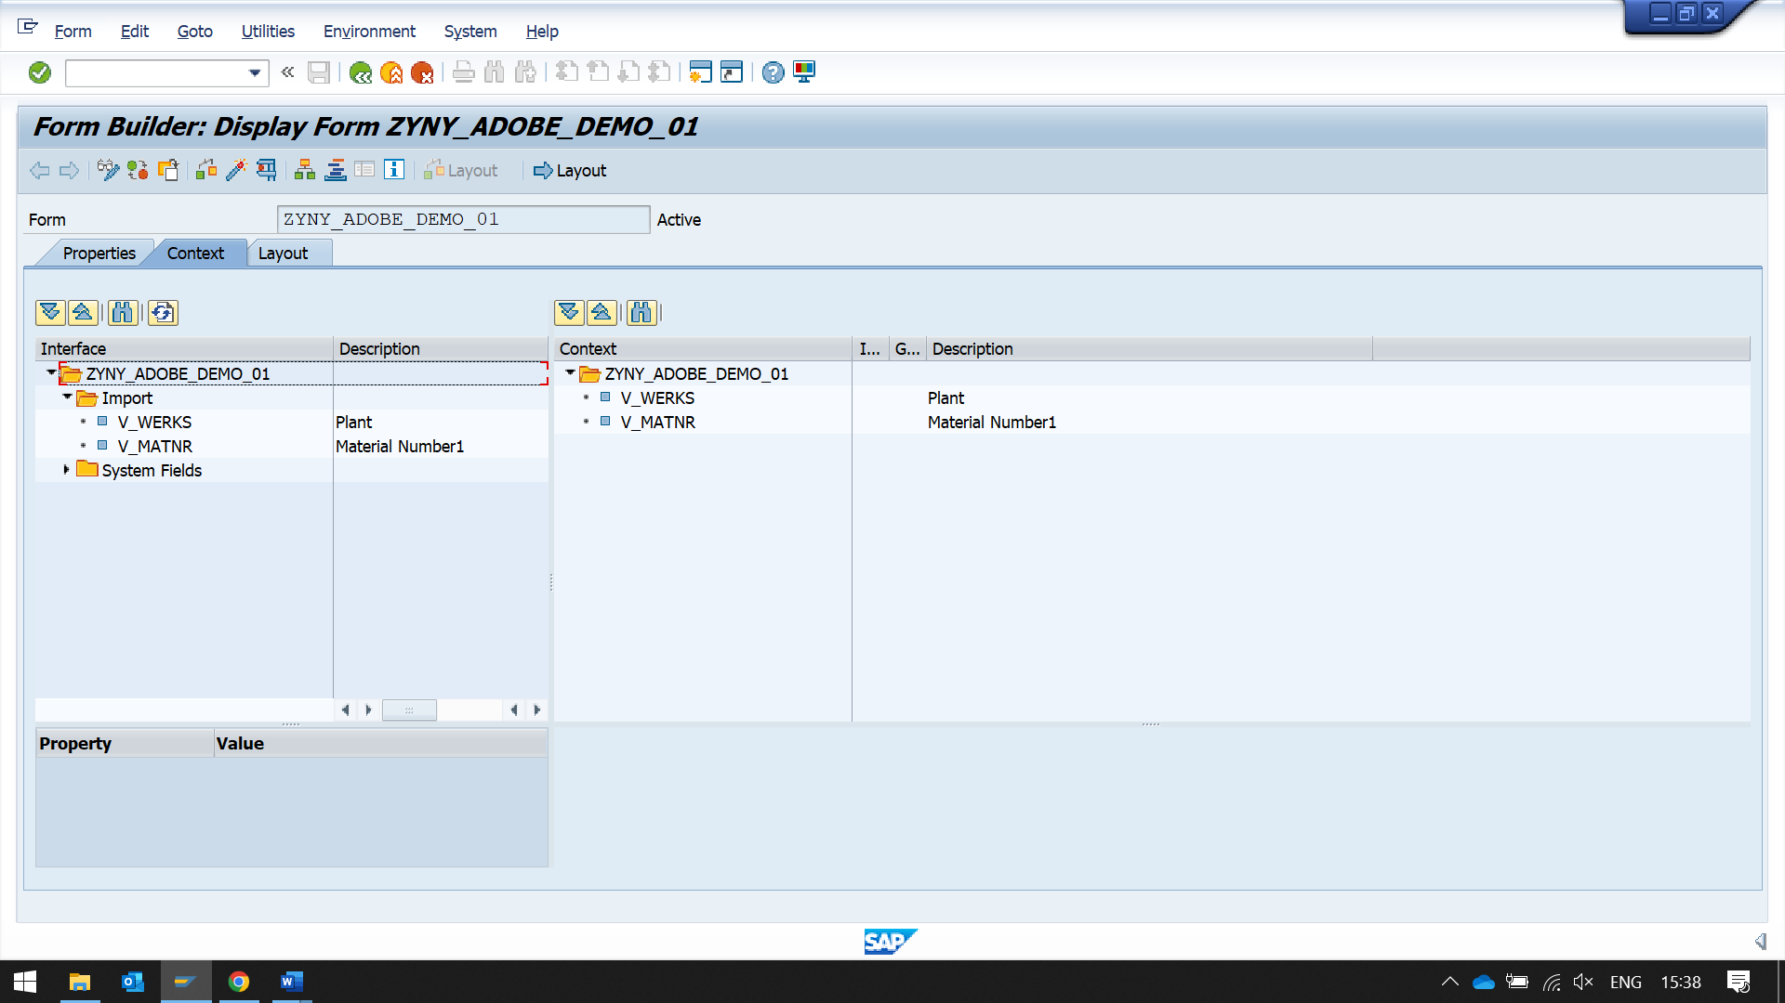DRAG AND DROP IMPORT FIELDS FROM INPUT SECTIO TO THE

CONTEXT SECTION (SPECIFICALLY ON THE FOLDER)

GO TO LAYOUT TAB

THEN IN PALLETE -> DATA VIEW

THIS WILL DISPLAY THE DATA VIEW ON THE LEFT

DRAG AND DROP PARAMETERS FROM THE THIS SECTION TO THE DESIGN VIEW

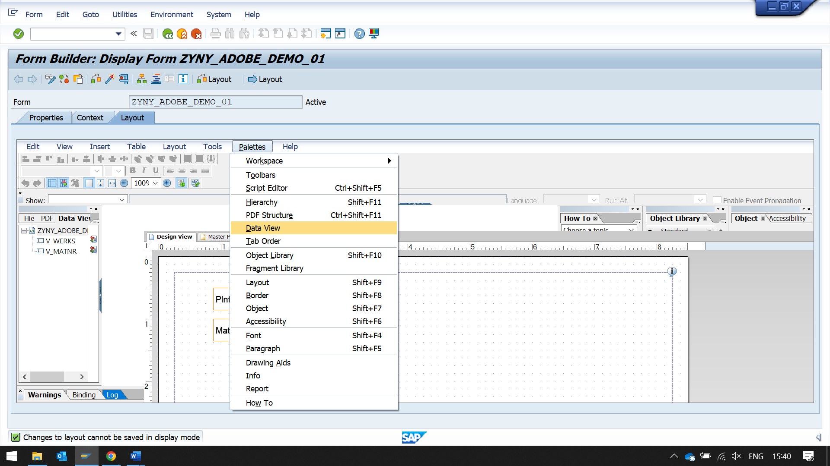

WHILE EXECUTING THE PROGRAM USE DEVICE OTHER THAN (LOCL)

NOW TO USE THIS CALL THIS ADOBE FORM FROM REPORT

WRITE A REPORT

REPORT ZYNY_ADOBE_FORM_DEMO_01.  
  
PARAMETERS : P_MATNR TYPE MATNR,  
             P_WERKS TYPE WERKS_D.  
  
DATA : CP_OUTPARAM TYPE SFPOUTPUTPARAMS.  
  
DATA : FPNAME TYPE FPNAME.  
  
INITIALIZATION.  
FPNAME = 'ZYNY_ADOBE_DEMO_01'.  
  
  
CALL FUNCTION 'FP_JOB_OPEN'  
  CHANGING  
    IE_OUTPUTPARAMS       = CP_OUTPARAM  
 EXCEPTIONS  
   CANCEL                = 1  
   USAGE_ERROR           = 2  
   SYSTEM_ERROR          = 3  
   INTERNAL_ERROR        = 4  
   OTHERS                = 5  
          .  
IF SY-SUBRC <> 0.  
* Implement suitable error handling here  
ENDIF.  
  
CALL FUNCTION 'FP_FUNCTION_MODULE_NAME'  
  EXPORTING  
    I_NAME                     = FPNAME  
* IMPORTING  
*   E_FUNCNAME                 =  
*   E_INTERFACE_TYPE           =  
*   EV_FUNCNAME_INBOUND        =  
          .

